Case Study – 6
Title / Aim :- To perform various string operation using javascript.
- to perform basics of string
- work with strings: substring(), indexOf(), split(), replace().
- case study:
  - write a program to reverse a string.
  - WAP to count the number of vowels in a paragraph

Software/Tools Required :-
- Visual Studio Code (VS Code)
- Google Chrome / Any Web Browser
- HTML
- JavaScript

CODE:-
Index.html
<!DOCTYPE html>
<html lang="en">
<head>
<meta charset="UTF-8">
<meta name="viewport" content="width=device-width, initial-scale=1.0">
<title>Text Toolkit</title>
<link rel="stylesheet" href="style.css">
</head>
<body>
<div class="container">
<!-- Header -->
<header>
<div class="icon">🔤</div>
<h1>Text Toolkit</h1>
<p>Explore JavaScript String Operations</p>
</header>
<!-- Input -->
<section class="card">
<h2>📝 Enter Your Text</h2>
<textarea
id="inputText"
placeholder="Enter a sentence or paragraph here..."
></textarea>
<button onclick="analyzeText()">
Analyze Text
</button>
</section>
<!-- Basic String Operations -->
<section class="card">
<h2>🔧 String Operations</h2>
<div class="results">
<div class="result-box">
<h3>String Length</h3>
<p id="length">-</p>
</div>
<div class="result-box">
<h3>Substring</h3>
<p id="substring">-</p>
</div>
<div class="result-box">
<h3>Index of "a"</h3>
<p id="indexOf">-</p>
</div>
<div class="result-box">
<h3>Split</h3>
<p id="split">-</p>
</div>
<div class="result-box">
<h3>Replace</h3>
<p id="replace">-</p>
</div>
</div>
</section>
<!-- Case Study -->
<section class="card">
<h2>📊 Case Study Results</h2>
<div class="case-study">
<div>
<h3>🔄 Reversed String</h3>
<p id="reverse">-</p>
</div>
<div>
<h3>🔤 Number of Vowels</h3>
<p id="vowels">-</p>
</div>
</div>
</section>
</div>
<script src="script.js"></script>
</body>
</html>

Style.css
* {
box-sizing: border-box;
margin: 0;
padding: 0;
font-family: Arial, sans-serif;
}
body {
background: #d6a27f;
color: #1f2937;
padding: 30px 20px;
}
.container {
max-width: 900px;
margin: auto;
}
/* Header */
header {
background: #7c3aed;
color: white;
text-align: center;
padding: 35px;
border-radius: 18px;
margin-bottom: 25px;
}
header .icon {
font-size: 45px;
}
header h1 {
font-size: 32px;
margin: 10px 0;
}
header p {
color: #ede9fe;
}
/* Cards */
.card {
background: white;
padding: 25px;
margin-bottom: 20px;
border-radius: 15px;
box-shadow: 0 4px 12px rgba(0, 0, 0, 0.08);
}
.card h2 {
color: #6d28d9;
margin-bottom: 20px;
}
/* Textarea */
textarea {
width: 100%;
height: 180px;
padding: 15px;
border: 2px solid #ddd6fe;
border-radius: 10px;
resize: vertical;
font-size: 16px;
outline: none;
}
textarea:focus {
border-color: #7c3aed;
}
/* Button */
button {
width: 100%;
margin-top: 15px;
padding: 13px;
border: none;
border-radius: 8px;
background: #7c3aed;
color: white;
font-size: 16px;
font-weight: bold;
cursor: pointer;
}
button:hover {
background: #6d28d9;
}
/* Results */
.results {
display: grid;
grid-template-columns: repeat(2, 1fr);
gap: 15px;
}
.result-box {
background: #f5f3ff;
padding: 18px;
border-left: 4px solid #7c3aed;
border-radius: 8px;
}
.result-box h3 {
font-size: 15px;
margin-bottom: 10px;
}
.result-box p {
color: #4b5563;
word-break: break-word;
}
/* Case Study */
.case-study {
display: grid;
grid-template-columns: 1fr 1fr;
gap: 15px;
}
.case-study div {
background: #f5f3ff;
padding: 20px;
border-radius: 10px;
}
.case-study h3 {
margin-bottom: 10px;
}
.case-study p {
color: #4b5563;
word-break: break-word;
}
/* Mobile */
@media (max-width: 600px) {

.results,
.case-study {
grid-template-columns: 1fr;
}
}

Script.js
// Main function
function analyzeText() {
// Get input from textarea
const text = document.getElementById("inputText").value;
// Check empty input
if (text.trim() === "") {
alert("Please enter some text.");
return;
}
// --------------------------------
// BASIC STRING OPERATIONS
// --------------------------------
// length
const length = text.length;
// substring()
// Extract characters from index 0 to 10
const substring = text.substring(0, 10);
// indexOf()
// Find the position of the first "a"
const index = text.toLowerCase().indexOf("a");
// split()
// Split paragraph into words
const words = text.trim().split(/\s+/);
// replace()
// Replace the first occurrence of "JavaScript"
const replaced = text.replace(
/JavaScript/i,
"JavaScript Programming"
);
// -------------------------------
// CASE STUDY 1
// REVERSE A STRING
// --------------------------------
const reversed = text
.split("")
.reverse()
.join("");
// -------------------------------
// CASE STUDY 2
// COUNT VOWELS
// --------------------------------
let vowelCount = 0;
for (const character of text.toLowerCase()) {
if ("aeiou".includes(character)) {
vowelCount++;
}
}
// --------------------------------
// DISPLAY RESULTS
// --------------------------------
document.getElementById("length").textContent =
length;
document.getElementById("substring").textContent =
substring;
document.getElementById("indexOf").textContent =
index === -1 ? "Not found" : index;
document.getElementById("split").textContent =
`${words.length} words → [${words.join(", ")}]`;
document.getElementById("replace").textContent =
replaced;
document.getElementById("reverse").textContent =
reversed;
document.getElementById("vowels").textContent =
vowelCount;
}

Output :-
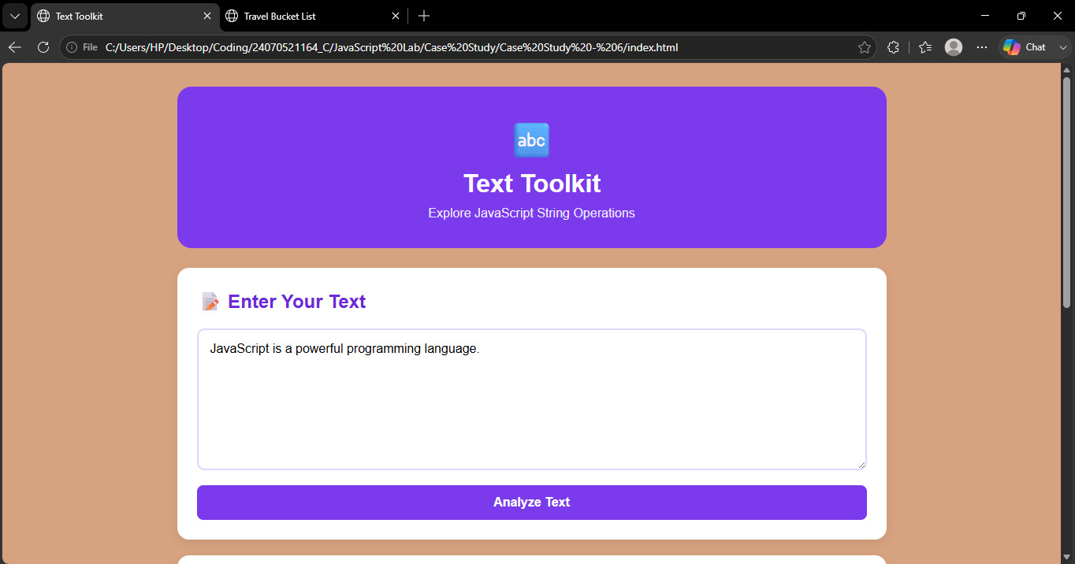

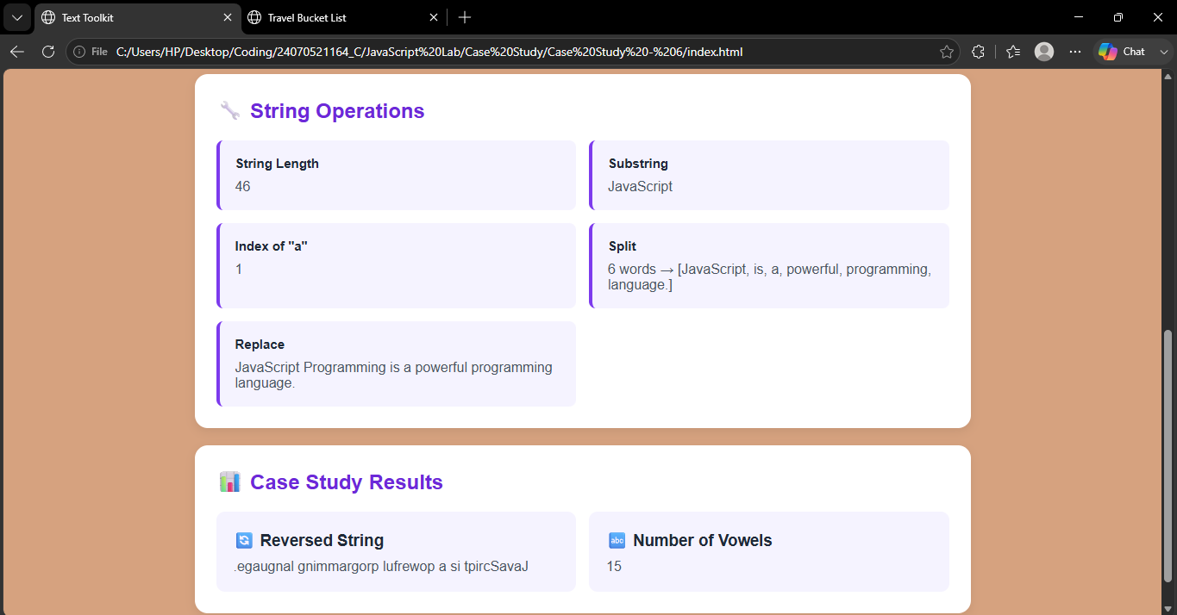

Result / Conclusion :-
The Text Toolkit webpage was successfully developed using HTML, CSS, and JavaScript. Various string operations such as substring(), indexOf(), split(), replace(), and length were successfully implemented. The program also reverses the given string using split(), reverse(), and join(). The number of vowels in the entered paragraph is calculated using a loop and string operations. Thus, the experiment provided practical understanding of JavaScript string manipulation and text processing.

